Power over the devil’s kingdom!

Catch up review!

Israel has committed the unpardonable sin.

Everything has now changed.

The Kingdom is postponed.

The message is no longer national but individual.

Jesus now speaks in Parables!

No more signs to the nation of Israel except the sign of Jonah!

The training is now of the twelve.

Miracles happen only by faith and not signs to the nation to believe.

Last time we saw Jesus' power over creation as He muzzles the wind and the waves.

Now we will see HIS power over the very power the Pharisees said He was under.

Once again, the devil’s kingdom is divided and torn apart!!!!!

Matthew 8:28 When He had come to the other side, to the country of the Gergesenes, there met Him two demon-possessed men, coming out of the tombs, exceedingly fierce, so that no one could pass that way.

29 And suddenly they cried out, saying, “What have we to do with You, Jesus, You Son of God? Have You come here to torment us before the time?” 30 Now a good way off from them there was a herd of many swine feeding.

31 So the demons begged Him, saying, “If You cast us out, permit us to go away into the herd of swine.”32 And He said to them, “Go.” So when they had come out, they went into the herd of swine. And suddenly the whole herd of swine ran violently down the steep place into the sea, and perished in the water.

33 Then those who kept them fled; and they went away into the city and told everything, including what had happened to the demon-possessed men.

34 And behold, the whole city came out to meet Jesus. And when they saw Him, they begged Him to depart from their region.

Some things to get out of the way that critics love to harp on in ignorance…

Matthew = Gadarenes

Mark and Luke = Gerasenes

The whole area is called the Decapolis

Matthew focuses on the region which also has a city by that name.

Mark and Luke focus on the city in the region!

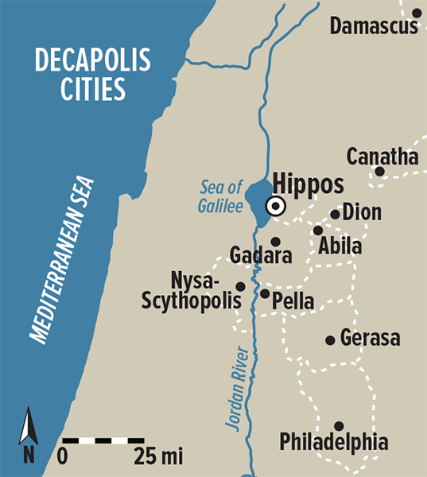

Matthew = 2 demonized men the larger context

Mark and Luke = 1 individual the worse of the two and focal point

“In a commonly accepted manner of reporting at that time… This type of reporting will appear again later in the Gospels. It may also indicate that while both men were demonized, only one of them had to deal with a whole legion of demons.”

Arnold G. Fruchtenbaum. baf-yes2 (Kindle Locations 7758-7761). Kindle Edition.

Now to more important things!

What do the demons acknowledge:

1. They know who Jesus is, even though the Jewish leaders and Gentile people of the city/region do not!

PROPHECY ALERT…

Isa 53:1 Who has believed our report? And to whom has the arm of the LORD been revealed?

3 He is despised and rejected by men, A Man of sorrows and acquainted with grief. And we hid, as it were, our faces from Him; He was despised, and we did not esteem Him.

Irony…The very most wicked of beings acknowledge Jesus but the leaders to this day do not???

2. The very most wicked of beings, in fear fall at HIS feet!

Mark 5:6 When he saw Jesus from afar, he ran and worshiped Him.

Phil 2:9 Therefore God also has highly exalted Him and given Him the name which is above every name, 10 that at the name of Jesus every knee should bow, of those in heaven, and of those on earth,

and of those under the earth, 11 and that every tongue should confess that Jesus Christ is Lord, to the glory of God the Father.

3. And lastly, they know of a real place and a real future that they and all who are unregenerate WILL FACE!

Mark 5:7 And he cried out with a loud voice and said, “What have I to do with You, Jesus, Son of the Most High God? I implore You by God that You do not torment me.”

Matthew 8:29… Have You come here to torment us before the time?”

He has already commanded them to come out, at which they begin to appeal to Jesus in the form of WHY, WHY?

Jesus then begins to use a standard practice of the time, to know the name of the wicked ones.

Luke 8:30 Jesus asked him, saying, “What is your name?” And he said, “Legion,” because many demons had entered him.

They now know their time is short!

Luke 8:31 And they begged Him that He would not command them to go out into the abyss.

Afterlife places the Bible describes:

Luke 16:22 “So it was that the beggar died, and was carried by the angels to Abraham’s bosom. The rich man also died and was buried. 23 “And being in torments in Hades, he lifted up his eyes and saw Abraham afar off, and Lazarus in his bosom. 24 “Then he cried and said, ‘Father Abraham, have mercy on me,

and send Lazarus that he may dip the tip of his finger in water and cool my tongue; for I am tormented in this flame.’

25 “But Abraham said, ‘Son, remember that in your lifetime you received your good things, and likewise Lazarus evil things; but now he is comforted and you are tormented. 26 ‘And besides all this, between us and you there is a great gulf fixed, so that those who want to pass from here to you cannot, nor can those from there pass to us.’

27 “Then he said, ‘I beg you therefore, father, that you would send him to my father’s house, 28 ‘for I have five brothers, that he may testify to them, lest they also come to this place of torment.’ 29 “Abraham said to him, ‘They have Moses and the prophets; let them hear them.’

30 “And he said, ‘No, father Abraham; but if one goes to them from the dead, they will repent.’ 31 “But he said to him, ‘If they do not hear Moses and the prophets, neither will they be persuaded though one rise from the dead.’ ”

Old Test before the resurrection

Sheol or Hades: Believers went to Abraham’s bosom. Unbelievers had three places; one was Hell for humans the second was Tartarus which was death row for a particular group of evil angels and deep pits of darkness.

2 Peter 2: 4 For if God did not spare the angels who sinned, but cast them down to hell and delivered them into chains of darkness, to be reserved for judgment; 5 and did not spare the ancient world,

but saved Noah, one of eight people, a preacher of righteousness, bringing in the flood on the world of the ungodly;

Gen 6:1 Now it came to pass, when men began to multiply on the face of the earth, and daughters were born to them, 2 that the sons of God saw the daughters of men, that they were beautiful; and they took wives for themselves of all whom they chose…

4 There were giants on the earth in those days, and also afterward, when the sons

of God came in to the daughters of men and they bore children to them. Those were the mighty men who were of old, men of renown.

The third place of Sheol is the Abyss which is the temporary confinement of evil demons note, temporary…

Rev 9:1 Then the fifth angel sounded: And I saw a star fallen from heaven to the earth. To him was given the key to the bottomless pit. 2 And he opened the bottomless pit, and smoke arose out of the pit like the smoke of a great furnace.

So the sun and the air were darkened because of the smoke of the pit. 3 Then out of the smoke locusts came upon the earth. And to them was given power, as the scorpions of the earth have power.

Rev 20:1 Then I saw an angel coming down from heaven, having the key to the bottomless pit and a great chain in his hand. 2 He laid hold of the dragon, that serpent of old, who is the Devil and Satan, and bound him for a thousand years; 3 and he cast him into the bottomless pit,

and shut him up, and set a seal on him, so that he should deceive the nations no more till the thousand years were finished. But after these things he must be released for a little while.

When Christ died much changed. He was in the tomb but His soul to Paradise.

Christ Himself did not go to Hell but the paradise side of Sheol!

Luke 23:43 And Jesus said to him, “Assuredly, I say to you, today you will be with Me in Paradise.”

Between His death and resurrection

1 Peter 3:18 For Christ also suffered once for sins, the just for the unjust, that He might bring us to God, being put to death in the flesh but made alive by the Spirit, 19 by whom also He went and preached to the spirits in prison,

Christ victorious (Rom 3:25) freed the righteous and preached Judgement to all the unsaved! Sealing their fate!

Revelation 20:13 The sea gave up the

dead who were in it, and Death and Hades delivered up the dead who were in them. And they were judged, each one according to his works. 14 Then Death and Hades were cast into the lake of fire. This is the second death.

When He arose from the dead…

John 20:17 Jesus said to her, “Do not cling to Me, for I have not yet ascended to My Father; but go to My brethren and say to them, ‘I am ascending to My Father and your Father, and to My God and your God.’ ”

Acts 1:9 Now when He had spoken these things, while they watched, He was taken up, and a cloud received Him out of their sight.

Next week: From breaking chains to preaching the Gospel!!!!!

