Parables of the Mystery Kingdom
May 23, 2026

The last soil!

Mat 13:23 “But he who received seed on the good ground is he who hears the word and understands it, who indeed bears fruit and produces: some a hundredfold, some sixty, some thirty.”

This is the believer who moves on to maturity.

The Epistles give many, many exhortations to move forward into this maturity.

Question: If the Christian walk was automatic and as soon as you’re saved

you walk victoriously, why all the exhortations to walk that way?

Due to some theologies and their errors, we have in the church neglected the fact that there can be failure in our walk. To those who teach otherwise, failure really isn’t an option and that only true believers walk well in Christ. There is no talk of rewards… for Heaven is the reward.

2 Cor 5:9 Therefore we make it our aim, whether present or absent, to be well pleasing to Him. 10 For we must all

appear before the judgment seat of Christ, that each one may receive the things done in the body, according to what he has done, whether good or bad. 11 Knowing, therefore, the terror of the Lord, we persuade men; but we are well known to God, and I also trust are well known in your consciences.

Paul just got done saying we have Heaven!

2Cor 5:1 For we know that if our earthly house, this tent, is destroyed, we have a building from God, a house not made with

hands, eternal in the heavens. 2 For in this we groan, earnestly desiring to be clothed with our habitation which is from heaven,

3 if indeed, having been clothed, we shall not be found naked. 4 For we who are in this tent groan, being burdened, not because we want to be unclothed, but further clothed, that mortality may be swallowed up by life. 5 Now He who has prepared us for this very thing is God, who also has given us the Spirit as a guarantee. 6 So we are always confident,

knowing that while we are at home in the body we are absent from the Lord. 7 For we walk by faith, not by sight. 8 We are confident, yes, well pleased rather to be absent from the body and to be present with the Lord.

1Cor 3:12 Now if anyone builds on this foundation with gold, silver, precious stones, wood, hay, straw, 13 each one’s work will become clear; for the Day will declare it, because it will be revealed by fire; and the fire will test each one’s work,

of what sort it is. 14 If anyone’s work which he has built on it endures, he will receive a reward. 15 If anyone’s work is burned, he will suffer loss; but he himself will be saved, yet so as through fire.

Eph 4:14 that we should no longer be children, tossed to and fro and carried about with every wind of doctrine, by the trickery of men, in the cunning craftiness of deceitful plotting, 15 but, speaking the truth in love, may grow up in all things into Him who is the head–Christ–

Eph 4:22 that you put off, concerning your former conduct, the old man which grows corrupt according to the deceitful lusts, 23 and be renewed in the spirit of your mind, 24 and that you put on the new man which was created according to God, in true righteousness and holiness…

30 And do not grieve the Holy Spirit of God, by whom you were sealed for the day of redemption.

Parable of the seed:

Mark 4:26 And He said, “The kingdom of God is as if a man should scatter seed

on the ground, 27 “and should sleep by night and rise by day, and the seed should sprout and grow, he himself does not know how. 28 “For the earth yields crops by itself: first the blade, then the head, after that the full grain in the head. 29 “But when the grain ripens, immediately he puts in the sickle, because the harvest has come.”

Two truths: The life is produced by the power of God. The Sower sows the WORD OF GOD!

Note this…

1Cor 2:1 And I, brethren, when I came to you, did not come with excellence of speech or of wisdom declaring to you the testimony of God. 2 For I determined not to know anything among you except Jesus Christ and Him crucified.

3 I was with you in weakness, in fear, and in much trembling. 4 And my speech and my preaching were not with persuasive words of human wisdom, but in demonstration of the Spirit and of power, 5 that your faith should not be in the

wisdom of men but in the power of God.

Also…

1Corinithians 3:4 For when one says, “I am of Paul,” and another, “I am of Apollos,” are you not carnal? 5 Who then is Paul, and who is Apollos, but ministers through whom you believed, as the Lord gave to each one? 6 I planted, Apollos watered, but God gave the increase.

7 So then neither he who plants is anything, nor he who waters, but God who gives the increase. 8 Now he who plants and he who waters are one, and

each one will receive his own reward according to his own labor. 9 For we are God’s fellow workers; you are God’s field, you are God’s building.

The Parable of the Tares

Mat 13:24 Another parable He put forth to them, saying: “The kingdom of heaven is like a man who sowed good seed in his field; 25 “but while men slept, his enemy came and sowed tares among the wheat and went his way. 26 “But when the grain had sprouted and produced a crop, then

the tares also appeared. 27 “So the servants of the owner came and said to him, ‘Sir, did you not sow good seed in your field? How then does it have tares?’

Mat 13:28 “He said to them, ‘An enemy has done this.’ The servants said to him, ‘Do you want us then to go and gather them up?’ 29 “But he said, ‘No, lest while you gather up the tares you also uproot the wheat with them. 30 ‘Let both grow together until the harvest, and at the time of harvest I will say to the reapers,
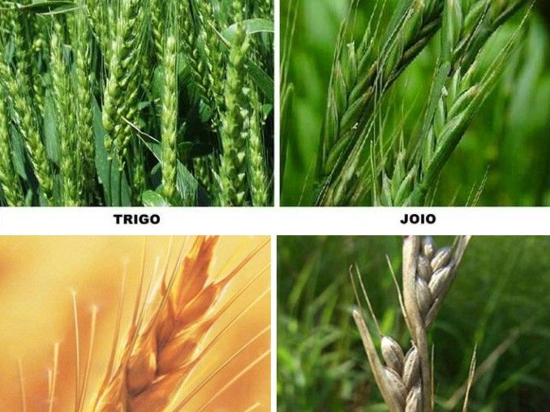

“First gather together the tares and bind them in bundles to burn them, but gather the wheat into my barn.” ’ ”

Jesus explains:

Mat 13:37 He answered and said to them: “He who sows the good seed is the Son of Man. 38 “The field is the world, the good seeds are the sons of the kingdom, but the tares are the sons of the wicked one. 39 “The enemy who sowed them is the devil, the harvest is the end of the age, and the reapers are the angels.

40 “Therefore as the tares are gathered and burned in the fire, so it will be at the end of this age. 41 “The Son of Man will send out His angels, and they will gather out of His kingdom all things that offend, and those who practice lawlessness,

42 “and will cast them into the furnace of fire. There will be wailing and gnashing of teeth. 43 “Then the righteous will shine forth as the sun in the kingdom of their Father. He who has ears to hear, let him hear!

They will exist side by side in the church???

Acts 20:28 “Therefore take heed to yourselves and to all the flock, among which the Holy Spirit has made you overseers, to shepherd the church of God which He purchased with His own blood.

29 “For I know this, that after my departure savage wolves will come in among you, not sparing the flock. 30 “Also from among yourselves men will rise up, speaking perverse things, to draw away the disciples after themselves.

31 “Therefore watch, and remember that for three years I did not cease to warn everyone night and day with tears.

2 Corinthians 11:13 For such are false apostles, deceitful workers, transforming themselves into apostles of Christ. 14 And no wonder! For Satan himself transforms himself into an angel of light. 15 Therefore it is no great thing if his ministers also transform themselves into ministers of righteousness, whose end will be according to their works.

13 For such are false apostles, deceitful workers, transforming themselves into apostles of Christ. 14 And no wonder! For Satan himself transforms himself into an angel of light. 15 Therefore it is no great thing if his ministers also transform themselves into ministers of righteousness, whose end will be according to their works.

Next week: More seeds, Treasures and Pearls!

