Salt, light and true righteousness!
Dec 7, 2025

Last week we talked about the woes against the leadership of Israel, and how people feared them. Also, the remnant of believers in Israel.

Today’s teaching:

Mat 5:13 “You are the salt of the earth; but if the salt loses its flavor, how shall it be seasoned? It is then good for nothing but to be thrown out and trampled underfoot by men. 14 “You are the light of the world. A city that is set on a hill cannot be hidden. 15 “Nor do they light a lamp and put it under a basket,

but on a lampstand, and it gives light to all who are in the house. 16 “Let your light so shine before men, that they may see your good works and glorify your Father in heaven.

Salt preserves, they are the remnant. Israel exists for the Jewish remnant. The Church exists for the remnant.

This contrasts with the Pharisee’s non-remnant witness.

Luke 16:5 Now when His disciples

had come to the other side, they had forgotten to take bread. 6 Then Jesus said to them,“Take heed and beware of the leaven of the Pharisees and the Sadducees.”

This applies for the church!

Col 4:5 Walk in wisdom toward those who are outside, redeeming the time. 6 Let your speech always be with grace, seasoned with salt, that you may know how you ought to answer each one.

Letting your light shine Which is Christ in you. This is contrast to the leaders of Israel.

Mat 8: 10 When Jesus heard it, He marveled, and said to those who followed, “Assuredly, I say to you, I have not found such great faith, not even in Israel! 11“And I say to you that many will come from east and west, and sit down with Abraham, Isaac, and Jacob in the kingdom of heaven.

12 “But the sons of the kingdom will be cast out into outer darkness.

There will be weeping and gnashing of teeth.”

Mat 3:9 “and do not think to say to yourselves, ‘We have Abraham as our father.’ For I say to you that God is able to raise up children to Abraham from these stones.

This also applies to the church!

1 Thess 5:4 But you, brethren, are not in darkness, so that this Day should overtake you as a thief. 5 You are all sons of light and sons of the day. We are not of the night nor of darkness.

6 Therefore let us not sleep, as others do, but let us watch and be sober. 7 For those who sleep, sleep at night, and those who get drunk are drunk at night. 8 But let us who are of the day be sober, putting on the breastplate of faith and love, and as a helmet the hope of salvation.

So Christian…

Mat 5:16 “Let your light so shine before men, that they may see your good works and glorify your Father in heaven.

True Righteousness under the Mosaic Law, as defined by the King of Kings!

Mat 5:17 “Do not think that I came to destroy the Law or the Prophets. I did not come to destroy but to fulfill. 18 “For assuredly, I say to you, till heaven and earth pass away, one jot or one tittle will by no means pass from the law till all is fulfilled. 19 “Whoever therefore breaks one of the least of these commandments, and teaches men so, shall be called least in the kingdom of heaven;

but whoever does and teaches them, he shall be called great in the kingdom of heaven. 20 “For I say to you, that unless your righteousness exceeds the righteousness of the scribes and Pharisees, you will by no means enter the kingdom of heaven.

Was this confusing? Absolutely, if you do not remember these same teachings of Christ!

First Jesus did not come to abolish but fulfill the true Mosaic Law, unlike the leader’s Mishnah rabbinical oral law.

He shows the heart of God revealing Himself in the true Law. Along with revealing peace and co-existence with others.

Romans 7:12 Therefore the law is holy, and the commandment holy and just and good.

Not one smallest “yod” letter… or the smallest stroke of a letter “Tittle” will pass away till ALL IS FULFILLED!

This means all the law Jesus came to fulfill

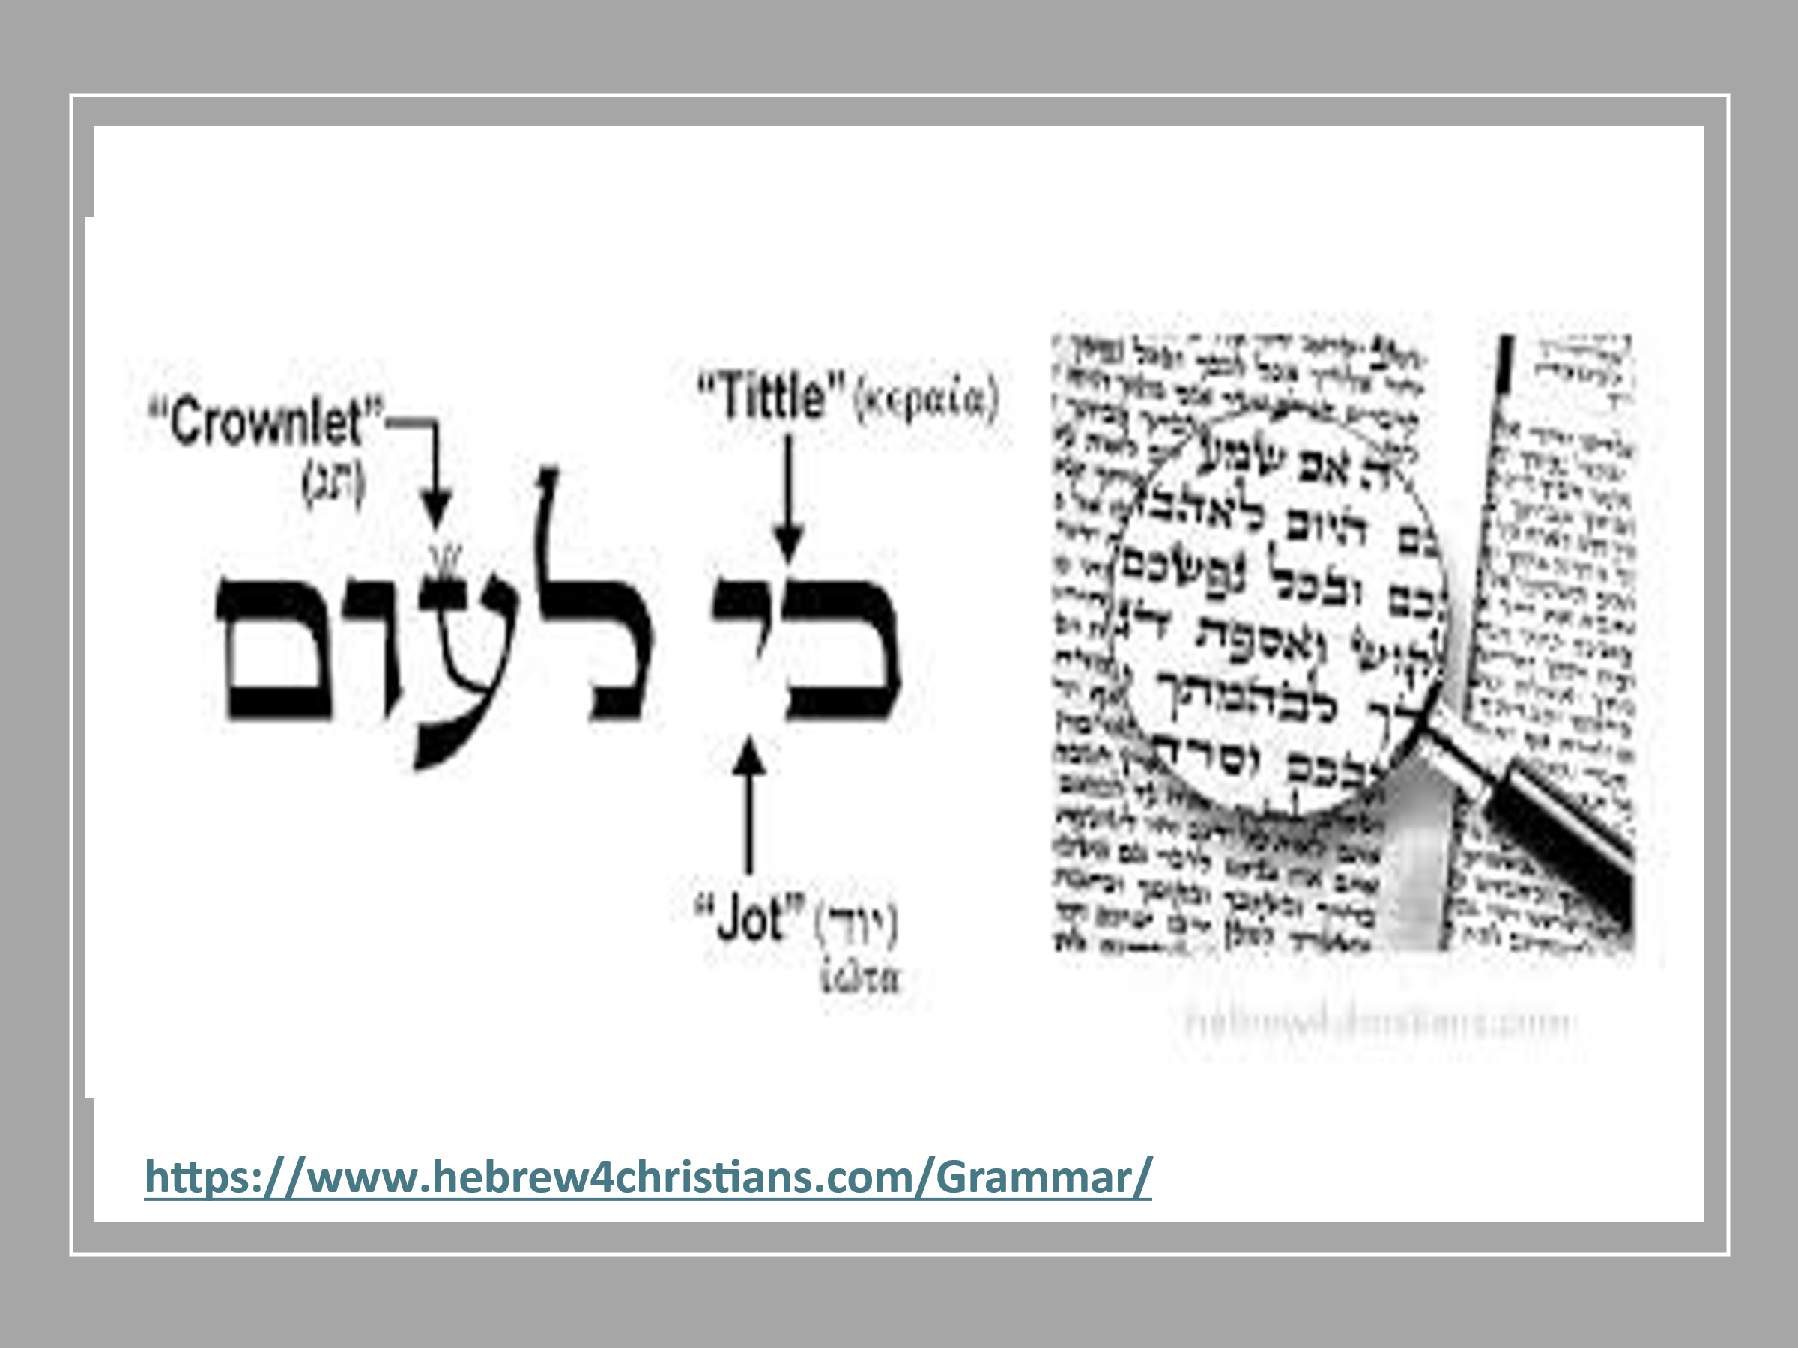

Some try to break the Law into this:

Moral, Civil, and Ceremonial

This will not do, Jesus says ALL! Which is From the smallest to the greatest.

Remember:

Galatians 4:4 But when the fullness of the time had come, God sent forth His Son, born of a woman, born under the law,

However, when He said, IT IS FINISHED!

Mat 27:51 Then, behold, the veil of the temple was torn in two from top to bottom; and the earth quaked, and the

rocks were split,

This was now in effect:

Hebrews 9:7 But into the second part the high priest went alone once a year, not without blood, which he offered for himself and for the people’s sins committed in ignorance;

8 the Holy Spirit indicating this, that the way into the Holiest of All was not yet made manifest while the first tabernacle was still standing. 9 It was symbolic for the present time in which both gifts and sacrifices are offered

which cannot make him who performed the service perfect in regard to the conscience– 10 concerned only with foods and drinks, various washings, and fleshly ordinances imposed until the time of reformation.

11 But Christ came as High Priest of the good things to come, with the greater and more perfect tabernacle not made with hands, that is, not of this creation. 12 Not with the blood of goats and calves, but with His own blood He entered

the Most Holy Place once for all, having obtained eternal redemption. 13 For if the blood of bulls and goats and the ashes of a heifer, sprinkling the unclean, sanctifies for the purifying of the flesh,

14 how much more shall the blood of Christ, who through the eternal Spirit offered Himself without spot to God, cleanse your conscience from dead works to serve the living God? 15 And for this reason He is the Mediator of the new covenant, by means of death,

for the redemption of the transgressions under the first covenant, that those who are called may receive the promise of the eternal inheritance.

Remember…

Mat 5:20 “For I say to you, that unless your righteousness exceeds the righteousness of the scribes and Pharisees, you will by no means enter the kingdom of heaven.

Being Jewish won’t save you!

The Mishnah/oral law will not save you!

Your righteousness will not save you!

No, instead, you must be born again!

Romans 3:19 Now we know that whatever the law says, it says to those who are under the law, that every mouth may be stopped, and all the world may become guilty before God. 20 Therefore by the deeds of the law no flesh will be justified in His sight, for by the law is the knowledge of sin.

It’s only JESUS!

Romans 3:21 But now the righteousness of God apart from the law is revealed, being witnessed by the Law and the Prophets, 22 even the righteousness of God, through faith in Jesus Christ, to all and on all who believe. For there is no difference;

23 for all have sinned and fall short of the glory of God, 24 being justified freely by His grace through the redemption that is in Christ Jesus,

Nest week: It was said… It was written!

