The corruptions that MUST BE DEALT WITH!!!!!!
Nov 24 2024

Temple rituals but without faith

Priesthood is corrupt

Formalism/ritualism that led to Pharisees

Scholasticism that led to Sadducees

I have loved you

They say how?????

THEME: A proper, reverence of God is the essential element in living well spiritually. Otherwise, you will fail to mature.

Failing to grow up in all things means you will be shallow in your reverence and knowledge of God.

Mal 1:6 “A son honors his father, And a servant his master. If then I am the Father, Where is My honor? And if I am a Master, Where is My reverence? Says the LORD of hosts To you priests who despise My name. Yet you say, ‘In what way have we despised Your name?’

Lack of discernment

Eph 4:14 that we should no longer be children, tossed to and fro and carried about with every wind of doctrine, by the trickery of men, in the cunning craftiness of deceitful plotting,

15 but, speaking the truth in love, may grow up in all things into Him who is the head–Christ–

Because of this lack, God must get their attention by consequences and promises.

Note: Malachi 2:2, 5; 3:5, 16; 4:2

2:2 If you will not hear, And if you will not take it to heart, To give glory to My name,” Says the LORD of hosts, “I will send a curse upon you, And I will curse your blessings. Yes, I have cursed them already, Because you do not take it to heart.

3:5 And I will come near you for judgment; I will be a swift witness Against sorcerers, Against adulterers, Against perjurers, Against those who exploit wage earners and widows and orphans, And against those who turn away an alien– Because they do not fear Me,” Says the LORD of hosts.

3:4-5 “Behold, I will rebuke your descendants And spread refuse on your faces, The refuse of your solemn feasts; And one will take you away with it. 4 Then you shall know that I have sent this commandment to you, That My covenant with Levi may continue,” Says the LORD of hosts.

4:2 But to you who fear My name The Sun of Righteousness shall arise With healing in His wings; And you shall go out And grow fat like stall-fed calves.

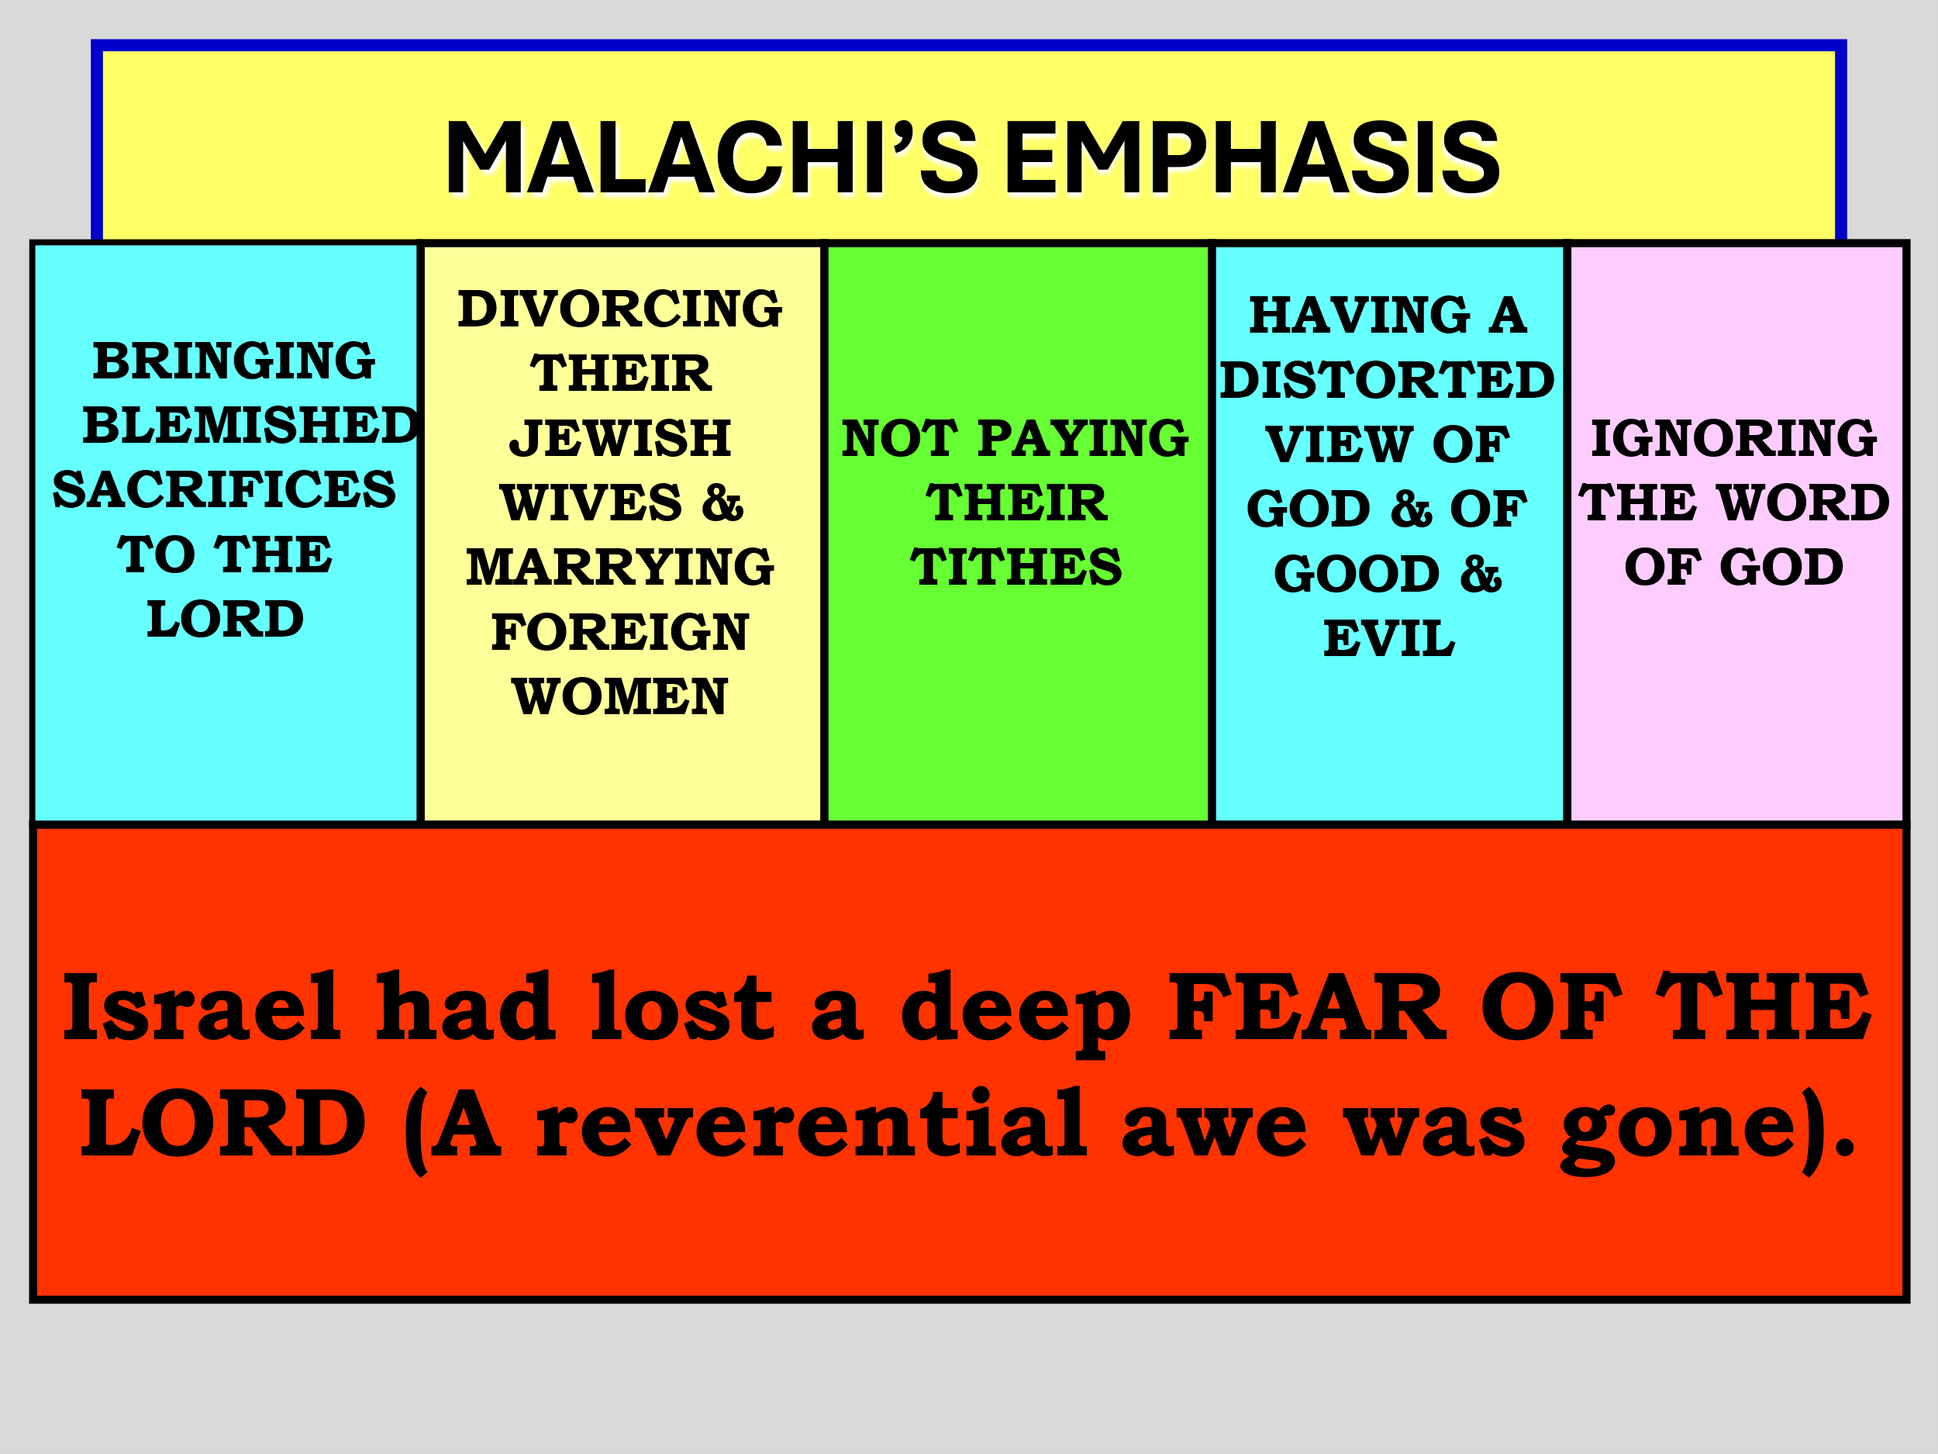

The problem is the PRIESTS, and they have been a problem all along. They were called to guide the people to the Lord but instead they led them astray.

2:7 “For the lips of a priest should keep knowledge, And people should seek the law from his mouth; For he is the messenger of the LORD of hosts. 8 But you have departed from the way; You have caused many to stumble at the law. You have corrupted the covenant of Levi,” Says the LORD of hosts.

9 “Therefore I also have made you contemptible and base Before all the people, Because you have not kept My ways But have shown partiality in the

law.”

Because the teaching is bad, the people are bad.

They are calling good evil and evil good!

They are divorcing their wives and marrying pagan ones.

GOD IS WEARIED !!!!!!!!

This is how far they have drifted…

2:17 You have wearied the LORD with your words; Yet you say, “In what way have we wearied Him?” In that you say, “Everyone who does evil Is good in the sight of the LORD, And He delights in them,” Or, “Where is the God of justice?”

Evil is still evil and good is still good, REGARDLESS WHAT PEOPLE OR CULTURE SAY!

To say anything else is to call God UNJUST! vs 17 Or, “Where is the God of justice?”

Just remember cultures fade away and people fade away, but the WORD OF GOD STANDS FOREVER!

Remember:

Where are the Pharoah's today?

Where are the Babylonians?

Where are the Persians?

Where are the Greeks?

Where are the Roman Caeser's

Where are the despots and dictators?

Where are ALL the wicked rulers of the past?

Mal 3:6 “For I am the LORD, I do not change; Therefore you are not consumed, O sons of Jacob.

This IS THE FUTURE, THERE IS NO OTHER.

Mal 4:1 “For behold, the day is coming, Burning like an oven, And all the proud, yes, all who do wickedly will be stubble. And the day which is coming shall burn them up,”

Says the LORD of hosts, “That will leave them neither root nor branch.

2 But to you who fear My name The Sun of Righteousness shall arise With healing in His wings; And you shall go out And grow fat like stall-fed calves. 3 You shall trample the wicked, For they shall be ashes under the soles of your feet On the day that I do this,” Says the LORD of hosts. 4 “Remember the Law of Moses, My servant, Which I commanded him in Horeb for all Israel, With the statutes and judgments.

Today is the same we must listen to the revealed truth of God. Then it was the Law of Moses. Today……

Jeremiah 31:31 “Behold, the days are coming, says the LORD, when I will make a new covenant with the house of Israel and with the house of Judah– 32 “not according to the covenant that I made with their fathers in the day that I took them by the hand to lead them out of the land of Egypt, My covenant which they broke, though I was a husband to them, says the LORD.

33 “But this is the covenant that I will make with the house of Israel after those days, says the LORD: I will put My law in their minds, and write it on their hearts; and I will be their God, and they shall be My people.

34 “No more shall every man teach his neighbor, and every man his brother, saying, ‘Know the LORD,’ for they all shall know Me, from the least of them to the greatest of them, says the LORD. For I will forgive their iniquity, and their sin I will remember no more.”

Hebrews 9:13 In that He says, “A new covenant,” He has made the first obsolete. Now what is becoming obsolete and growing old is ready to vanish away.

Heb 8:6 But now He has obtained a more excellent ministry, inasmuch as He is also Mediator of a better covenant, which was established on better promises.

Heb 10:1 For the law, having a shadow of the good things to come, and not the very image of the things, can never with these same sacrifices, which they offer continually year by year, make those who

approach perfect. 2 For then would they not have ceased to be offered? For the worshipers, once purified, would have had no more consciousness of sins. 3 But in those sacrifices there is a reminder of sins every year. 4 For it is not possible that the blood of bulls and goats could take away sins.

10:11 And every priest stands ministering daily and offering repeatedly the same sacrifices, which can never take away sins. 12 But this Man, after He had offered one sacrifice for sins forever, sat down at the right hand of God, 13 from that time waiting till His enemies are made His footstool.

14 For by one offering He has perfected forever those who are being sanctified. 15 But the Holy Spirit also witnesses to us; for after He had said before,

16 “This is the covenant that I will make with them after those days, says the LORD: I will put My laws into their hearts, and in their minds I will write them,” 17 then He adds, “Their sins and their lawless deeds I will remember no more.” 18 Now where there is remission of these, there is no longer an offering for sin.

19 Therefore, brethren, having boldness to enter the Holiest by the blood of Jesus, 20 by a new and living way which He consecrated for us, through the veil, that is, His flesh,

21 and having a High Priest over the house of God, 22 let us draw near with a true heart in full assurance of faith, having our hearts sprinkled from an evil conscience and our bodies washed with pure water.

